Aim:
To design a user input form and perform client-side form validation using JavaScript to ensure correctness and completeness of data before submission.
Code:

HTML:

<!DOCTYPE html>
<html>
<head>
<title>Client Side Registration</title>
<link rel="stylesheet" href="ass3.css">
</head>
<body>

<div class="container">
<h2>Registration Form</h2>

<form id="registrationForm">
<input type="text" id="name" placeholder="Full Name">
<small class="error" id="nameError"></small>

<input type="email" id="email" placeholder="Email">
<small class="error" id="emailError"></small>

<input type="password" id="password" placeholder="Password">
<small class="error" id="passwordError"></small>

<input type="text" id="mobile" placeholder="Mobile Number">
<small class="error" id="mobileError"></small>

<textarea id="address" placeholder="Address"></textarea>
<small class="error" id="addressError"></small>

<input type="text" id="city" placeholder="City">
<small class="error" id="cityError"></small>

<input type="text" id="pincode" placeholder="Pincode">
<small class="error" id="pincodeError"></small>

<input type="text" id="country" placeholder="Country">
<small class="error" id="countryError"></small>

<button type="submit">Register</button>
</form>

<p id="successMessage"></p>
</div>

<script src="ass3.js"></script>
</body>
</html>

CSS:
* {
box-sizing: border-box;
font-family: Arial, sans-serif;
}

body {
background: linear-gradient(135deg, #1e3a8a, #0f172a);
display: flex;
justify-content: center;
align-items: center;
height: 100vh;
}

.container {
width: 400px;
background: white;
padding: 25px;
border-radius: 10px;
}

h2 {
text-align: center;
margin-bottom: 15px;
}

form {
display: flex;
flex-direction: column;
}

input, textarea {
margin-top: 10px;
padding: 8px;
border-radius: 5px;
border: 1px solid #ccc;
}

textarea {
resize: none;
height: 60px;
}

button {
margin-top: 15px;
padding: 10px;
border: none;
background: #1e3a8a;
color: white;
border-radius: 5px;
cursor: pointer;
}

button:hover {
background: #0f172a;
}

.error {
color: red;
font-size: 12px;
}

#successMessage {
color: green;
text-align: center;
margin-top: 10px;
}

JS:
document.getElementById("registrationForm").addEventListener("submit", function(e) {
e.preventDefault();

let valid = true;

// Get values
const name = document.getElementById("name").value.trim();
const email = document.getElementById("email").value.trim();
const password = document.getElementById("password").value.trim();
const mobile = document.getElementById("mobile").value.trim();
const address = document.getElementById("address").value.trim();
const city = document.getElementById("city").value.trim();
const pincode = document.getElementById("pincode").value.trim();
const country = document.getElementById("country").value.trim();

// Clear previous errors
document.querySelectorAll(".error").forEach(el => el.textContent = "");
document.getElementById("successMessage").textContent = "";

// Name validation
if (!/^[A-Za-z ]{3,}$/.test(name)) {
document.getElementById("nameError").textContent = "Name must contain only letters (min 3 characters)";
valid = false;
}

// Email validation
if (!/^\S+@\S+\.\S+$/.test(email)) {
document.getElementById("emailError").textContent = "Enter a valid email address";
valid = false;
}

// Password validation
if (!/^(?=.*[a-z])(?=.*[A-Z])(?=.*\d).{8,}$/.test(password)) {
document.getElementById("passwordError").textContent =
"Password must be 8+ chars with uppercase, lowercase & number";
valid = false;
}

// Mobile validation
if (!/^\d{10}$/.test(mobile)) {
document.getElementById("mobileError").textContent = "Mobile must be exactly 10 digits";
valid = false;
}

// Address validation
if (address.length < 5) {
document.getElementById("addressError").textContent = "Address must be at least 5 characters";
valid = false;
}

// City validation
if (!/^[A-Za-z ]+$/.test(city)) {
document.getElementById("cityError").textContent = "City must contain only letters";
valid = false;
}

// Pincode validation
if (!/^\d{6}$/.test(pincode)) {
document.getElementById("pincodeError").textContent = "Pincode must be exactly 6 digits";
valid = false;
}

// Country validation
if (country === "") {
document.getElementById("countryError").textContent = "Country cannot be empty";
valid = false;
}

if (valid) {
document.getElementById("successMessage").textContent = "Registration Successful!";
document.getElementById("registrationForm").reset();
}
});

Output:

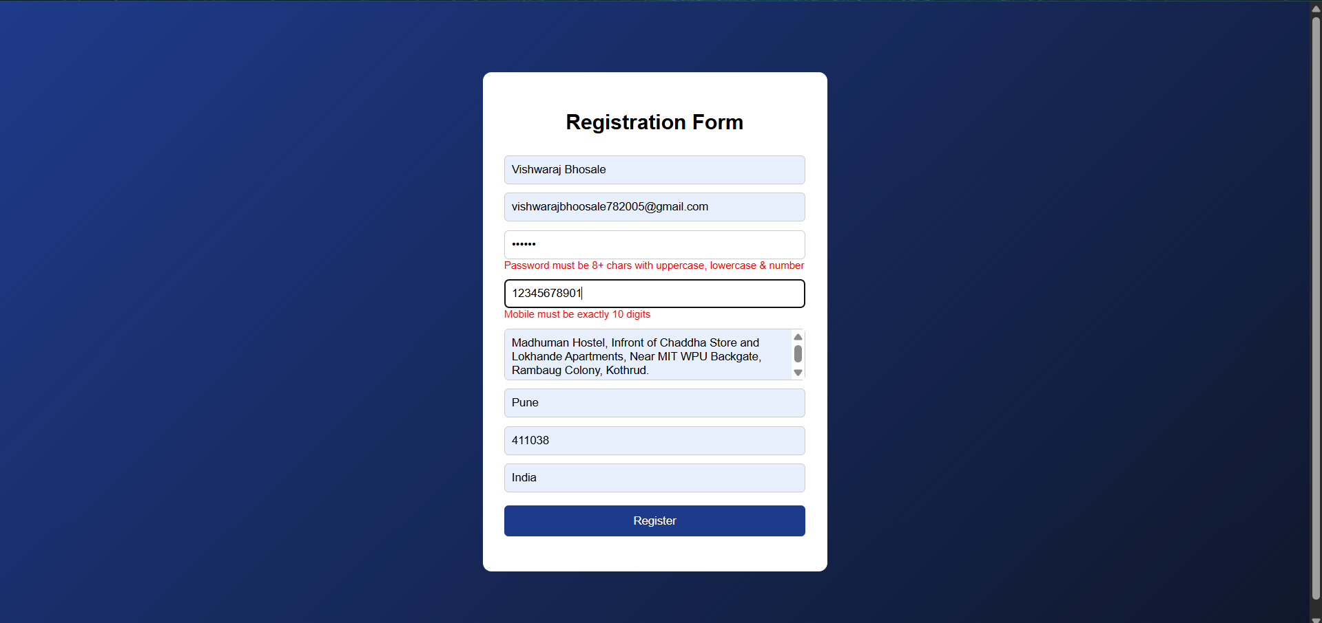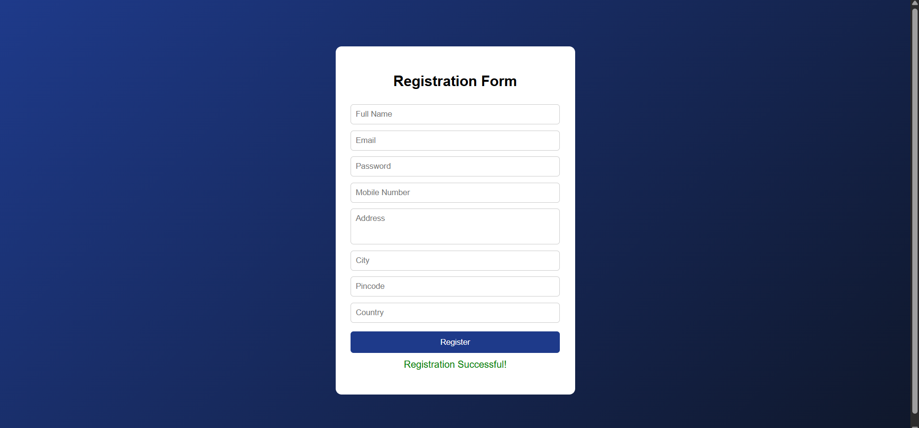

FAQ:
